**Success factors of open urban data for NbS planning, co-creation, participation, and implementation**

**Sales Pitch Text:**

NbS are typically highly visible, audible, and tangible interventions or even construction projects. But there is another side to them which is of profound importance: open urban data. The term refers to a wide variety of datasets, which may vary in scale, time reference, complexity, and provenance, but have in common that they represent information about urban spaces and are publicly accessible, mostly provided by a central administration, and can be searched, used, and analysed by anyone. Examples for open urban data may be green areas in the city, information about biodiversity, the locations of playgrounds and schools, traffic, traffic lights and public transport information, the availability of rental bicycles, cultural events or weather data. Accessible through central contact points, such as an *Urban Data Platform*, up-to-date urban data may support:

* the identification and evaluation of the most reasonable locations for NbS
* data-based citizen participation and co-creation using digital platforms
* the publication of monitoring results and their adoption in the local context, making evaluation and follow-up NbS research traceable, understandable, and comparable
* transparent and accountable NbS governance

In this brief, we delve into the success factors behind open urban data for NbS planning, co-creation, participation, implementation, and monitoring. A case study from the Free and Hanseatic City of Hamburg is presented to demonstrate the many benefits of using open urban data in the scope of the CLEVER Cities project.

**Further Information:**

| Urban Data Platform Hamburg | <https://www.en.urbandataplatform.hamburg/> | Website of the Urban Data Platform Hamburg with information about the available datasets and web applications |
| --- | --- | --- |
| UDP Cockpit | https://geoportal-hamburg.de/udp-cockpit/#/ | Visualization of main UDP_HH KPIs, such as amount of visitors of the UDP, amount of available datasets, most popular datasets and applications, new datasets |
| Geoportal Hamburg | <https://geoportal-hamburg.de/geo-online/> | Web map application to easily visualise datasets from the Urban Data Platform Hamburg |
| Masterportal | http://masterportal.org/ | Open Source Software to build geoportals, developed by the Free and Hanseatic City of Hamburg |
| Metadata Catalogue | https://metaver.de/portal/ | Central access point to search Metadata from several federal states of Germany |
| DIPAS | https://dipas.org/ | The first digital system without media discontinuity for citizen participation online and on site |
| CLEVER Data Hub | https://clevercities.eu/resources/clever-data-hub/ | The CLEVER Data Hub facilitates discovery, access, integration and evaluation of the data generated within the project to support the impact assessment by the CLEVER Monitor |
| Heavy Rain Drainage Analysis | https://clevercities.eu/fileadmin/user_upload/City_Publications/drainage-analysis-for-heavy-rainfall-neugraben-fischbek.pdf | Documentation of the Drainage Analysis for Heavy Rainfall – Neugraben-Fischbek |

**Graphics:**

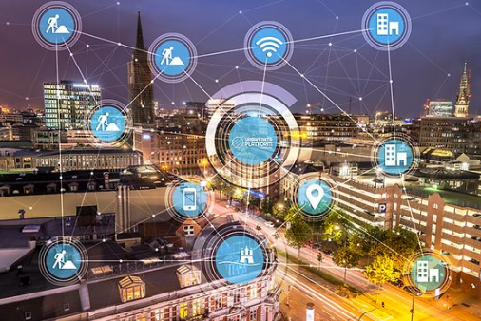

**©LGV**

This is a picture we commonly use to visualize the idea that the city is full of data sources, buildings and traffic and construction sites etc. emit data all the time, and we can make the most of it if we connect it so that it forms a network of urban data. This network, in which data silos no longer exist, can then be used for communication, planning, evaluation, and analysis.

**Ein Bild, das Diagramm enthält.
**

**Screenshot of the UDP Cockpit**

This is a screenshot of the UDP cockpit (link is in the table). The UDP Cockpit visualizes metadata about the Urban Data Platform Hamburg – for example, we can see that there are currenty more than 5,500 sensors in use and the geoportal (link is in the table) has had more than 290k visitors per month.