Digital co-creation in CLEVER Cities with DIPAS
A core goal of the CLEVER Cities project was to illuminate how co-creative processes can engage citizens in NbS planning and to make their contributions an integral part of such processes. The Digital Participation System of the City of Hamburg, Germany (DIPAS) served as a technical basis for accomplishing this aim, enabling residents to gather ideas, feedback and suggestions around local NbS developments.
DIPAS is a digital map application based on the publicly provided data of the Urban Data Platform Hamburg, developed since 2016 under the leadership of the Department of Urban Development and Housing. The tool enables project managers to extend informal citizen participation into the digital space and thus gives every citizen the opportunity to inform themselves about ongoing planning processes, to intersect different data sets on the project area on a digital map in order to be able to form a comprehensive opinion, to rate existing contributions, to geo-reference text contributions, to submit criticism, comments and new ideas, and to discuss the proposals with other users.
DIPAS was used for CLEVER Cities in the project area in Neugraben-Fischbek in the city of Hamburg on three occasions:
- 2018: Gathering of ideas for the project area and suggestions of potential roofs and buildings to install green roofs and facades
- 2020: Co-creation of design choices for a nature playground: citizens were invited to comment on four drafts for different spots in the future nature discovery area
- 2021: Refinement of the CLEVER Parcours, wherein the administration explained the basic idea for the future guidance system and asked for suggestions and ideas; citizens were requested to add new locations for the system and comment on the ideas of others
As CLEVER Cities does not only emphasize co-creation, but also focuses on social inclusion and the accessibility of projects and processes, the project partners of the Free and Hanseatic City of Hamburg merged these two strands in late 2020. It was then jointly decided to deploy CLEVER funds for the further development of DIPAS in the direction of accessibility. This helps user groups that rely on screen readers, for example, in their independent use and thus digital participation in planning processes with DIPAS. Since DIPAS is availabe as an open source software, this development benefits every downstream entity and future users, and all citizens who want to use the DIPAS system and participate in planning processes with and without restrictions. At the same time, planning benefits from an even greater breadth of content in the contributions and can include more perspectives in the planning.
Relevant Links:
- DIPAS: https://dipas.org/
- DIPAS: DIPAS Navigator: https://beteiligung.hamburg/navigator/#/
- Urban Data Platform Hamburg: https://www.en.urbandataplatform.hamburg/

Screenshot of the contribution map of the first DIPAS Participation process in CLEVER, 2018
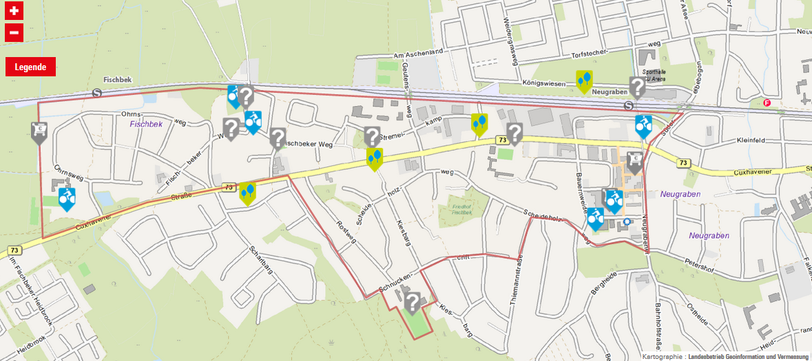
Screenshot of the DIPAS Navigator (27.04.2023)
